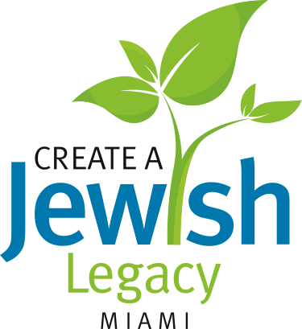
Barbara Black Goldfarb  Create a Jewish Legacy  Community Chair  Brian Bilzin  John Bussel  Moj Danial  Shelley Niceley Groff  Steve Kravitz  Norman Lipoff  Mike Segal  Lily Serviansky  Create a Jewish Legacy  Steering Committee  Ilana Saposnik  Create a Jewish Legacy  Coordinator | January 22, 2013  «Title» «FIRST» «Last»  «ADDRESS»  «Address_2»  «City», «State» «Zip»  Dear «GREETING_»,  January is Florida Jewish history month and as we reflect on Miami’s remarkable past and present, we remember that [INSERT your organization here] will turn [INSERT age of your organization] this coming [INSERT month of organization’s anniversary]. You may have heard the saying that the “present” is a gift. Our ancestors laid the foundation and built [INSERT your organization here] - their gift to us. Its long history is their legacy and we are the beneficiaries of their largesse.  This amazing gift of ours is now our responsibility to cherish, nourish and nurture and pass on to the generations that will follow us. It’s up to us to plan for and secure the future. This will be our legacy and our gift to them.  The Foundation of the Greater Miami Jewish Federation launched a new endowment program that will enable every member of the community to have a long-term impact on Jewish institutions at home, in Israel and around the world. The Create a Jewish Legacy (CJL) program represents a shared commitment by area agencies, synagogues and day schools to work together to collectively secure endowment gifts. We are proud to announce that we are one of the inaugural twelve partner organizations working collaboratively with these partners to assure a bright Jewish future.  We’d like to personally thank you for your contributions that have sustained us over these many years. During Florida Jewish history month, won’t you please consider helping secure the future our Jewish community via a gift in your will or estate plan? Every gift is meaningful. The simplest way to lave a legacy gift is through a bequest in your will. By leaving a gift through the Create a Jewish Legacy program, you can make one gift that can support the multiple organizations you cherish.  This is the time to ensure our collective Jewish future by building a strong, secure and permanent community endowment. We have enclosed a brochure about the Create a Jewish Legacy program with additional information. You may also visit us at www.jewishlegacy.org, (launching soon).  We are here to assist you every step of the way. Please feel free to contact me or any of the professionals here with questions and to start the process. To arrange a confidential, no obligation consultation with a Foundation professional, please call Ilana Saposnik, Create a Jewish Legacy Coordinator at 786-866-8435. [INSERT your organization’s professional contact information here].  Thank you for everything you do to support the Jewish community. We hope you’ll consider a gift in your will or estate plan to secure our next [INSERT age of your organization or 120] years – your gift to the generations that will follow us.  Sincerely,  [INSERT your President’s SIGNATURE here]  [ [INSERT your President’s NAME here]

